STAR WARS MANDO MONDAYS 11/2/2020 ONE SHEET

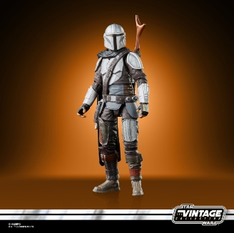
STAR WARS: THE VINTAGE COLLECTION 3.75-INCH THE MANDALORIAN
(HASBRO/Ages 4 years & up/Approx. Retail Price: $12.99/Available: Spring 2021)
Fans and collectors can imagine scenes from the STAR WARS Galaxy with this STAR WARS: THE VINTAGE COLLECTION 3.75-INCH THE MANDALORIAN, featuring original Kenner branding and inspired by live-action THE MANDALORIAN series on Disney Plus. Highly poseable with realistic detail, this quality 3.75-inch figure can be displayed in action figure and vehicle collections. Includes figure and 4 accessories. Available for pre-order at Amazon.
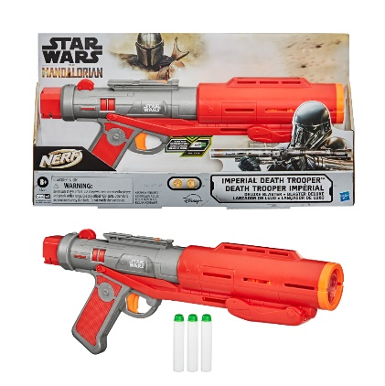
NERF STAR WARS IMPERIAL DEATH TROOPER Blaster
(HASBRO/Ages 8 years & up/Approx. Retail Price: $34.99/Available: Fall 2020)
Launch into galactic adventures as you imagine being an elite death trooper with this pump-action blaster that fires glow-in-the-dark darts! This NERF STAR WARS IMPERIAL DEATH TROOPER Blaster is inspired by blasters seen in THE MANDALORIAN live-action TV series on Disney Plus. GlowStrike technology creates light effects and charges the darts to make them glow when fired. Load 3 darts, pump the priming slide, and pull the trigger to fire 1 dart accompanied by laser blast sounds. Includes 3 Official Nerf Elite foam darts that are tested and approved for performance and quality. It’s fun for indoor and outdoor play and is a great gift for STAR WARS fans and Nerf battlers! Eyewear recommended and batteries required (not included). Available for pre-order at GameStop.

# # #

