ROGUE ONE: A STAR WARS STORY 2017 Product Descriptions
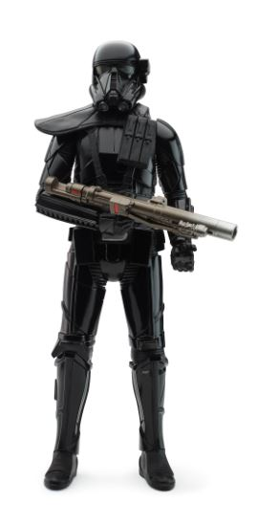

IMPERIAL DEATH TROOPER 12-INCH ELECTRONIC DUEL FIGURE
(Ages 4 years & up/Approx. Retail Price: $19.99/Available: Fall 2017)
Bring ROGUE ONE: A STAR WARS STORY to life with this 12-inch electronic figure! Jump into action with the elite IMPERIAL DEATH TROOPER, by squeezing the figure’s legs to activate authentic battle sounds. Each figure sold separately. Requires one 1.5V AA battery. Available at most major retailers and on HasbroToyShop.com. Compatible with the HASBRO STAR WARS STUDIOFX App.

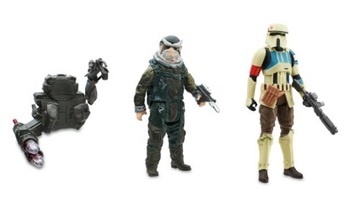STAR WARS 3.75-INCH DELUXE FIGURE 2-PACK Assortment
(Ages 4 years & up/Approx. Retail Price: $14.99/Available: Spring 2017)
Pick a side in the galactic battle between good and evil! Choose between the IMPERIAL DEATH TROOPER and REBEL COMMANDO PAO or the SCARIF STORMTROOPER and MOROFF from ROGUE ONE: A STAR WARS STORY, or relive the events from STAR WARS: THE FORCE AWAKENS with POE DAMERON and the FIRST ORDER SNOWTROOPER. Each 3.75-INCH DELUXE FIGURE 2-PACK comes with 2 figures and multiple accessories, including a dual-projectile launcher. Each pack sold separately. Available at most major retailers and on HasbroToyShop.com. Compatible with the HASBRO STAR WARS STUDIOFX App.
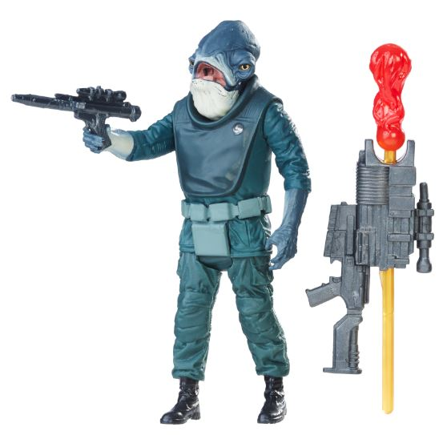
STAR WARS 3.75-INCH FIGURE Assortment
(Ages 4 years & up/Approx. Retail Price: $7.99/Available: Spring 2017)
Enter the world of STAR WARS and launch into action and adventure! Each 3.75-inch figure features five points of articulation and comes with their iconic battle accessories. Characters include heroes and villains from ROGUE ONE: A STAR WARS STORY such as JYN ERSO, K-2SO, IMPERIAL GROUND CREW, GALEN ERSO, and IMPERIAL STORMTROOPER, STAR WARS REBELS characters including KANAN JARRUS (Stormtrooper Disguise) and SABINE WREN, and KYLO REN and REY (JAKKU) from STAR WARS: THE FORCE AWAKENS. Each figure sold separately. Available at most major retailers and on HasbroToyShop.com. Compatible with the HASBRO STAR WARS STUDIOFX App.

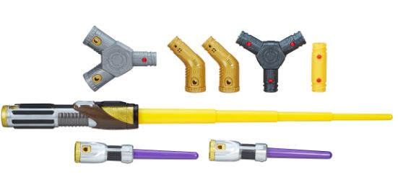STAR WARS BLADEBUILDERS JEDI KNIGHT LIGHTSABER
(Ages 4 years & up/Approx. Retail Price: $29.99/Available: Spring 2017)
Build a custom lightsaber fit for the most powerful Jedi in the galaxy! Extend the JEDI KNIGHT LIGHTSABER with a flick of the wrist and attach the double lightdaggers for close combat. Compatible with BLADEBUILDERS LIGHTSABER components, each sold separately. Includes yellow lightsaber, 2 purple lightdaggers, and 5 adjustable connectors. Available at most major retailers and on HasbroToyShop.com.

# # #

